**Registration**

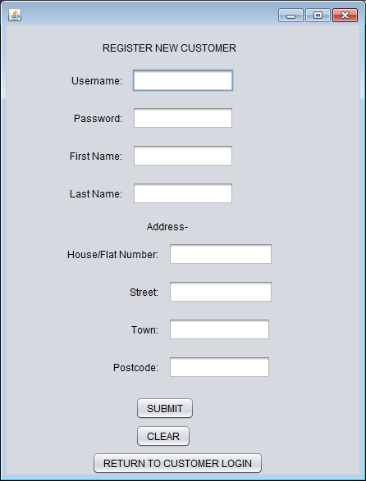

This is accessed via the REGISTER button inside the Customer login page

**ADD PRODUCT**

Staff View Products Add Product

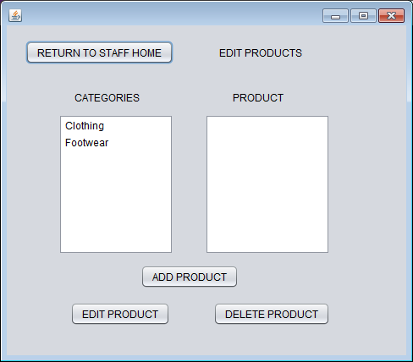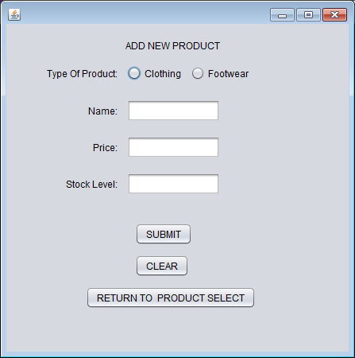

This is accessed via the MODIFY PRODUCTS

button inside the Staff home page

Add Product (Clothing Selected) Add Product (Footwear Selected)

